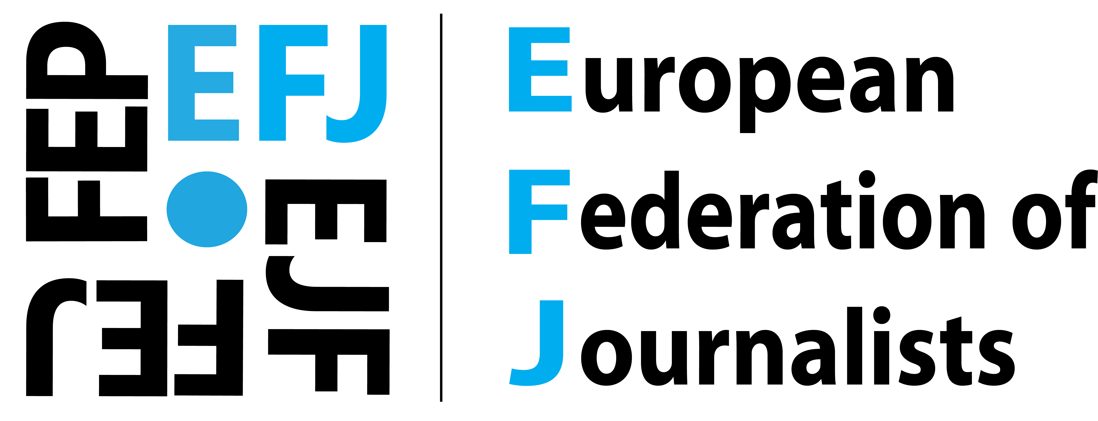

Dear xxx
Candidate for Member of the European Parliament,
As the largest organisation of journalists in Europe, representing over 320.000 journalists in 45 countries, the EFJ defends the professional and social rights of journalists and promote journalism as a public good.
Ahead of the European Elections on 26 May, the European Federation of Journalists (EFJ), has launched a Manifesto calling on all candidates for the members of the European Parliament to commit for the revival of a free and pluralistic media in Europe, so urgent in times of disinformation and losing trust in EU institutions.
The 2019 EP elections come at a turning point for the European Union which urgently needs to reconnect with its citizens and represent their interests. We wish a forward-looking EU where not only the economy and growth matter but where concrete action is taken to ensure that citizens’ right to know is guaranteed.
In recent years, journalists are witnessed their labour rights diminishing, working conditions deteriorating, quality in journalism dropping and the loss of public confidence in the media. Various forms of (self-)censorship as a result of political and economic pressures have also grown across Europe. Journalists have become the first casualty of these threats.
The EFJ has welcomed the willingness of the out-going European Parliament to support media freedom, authors’ rights, whistleblowers’ protection and more protection for new forms of work including for freelances and self-employed. We hope that the new European Parliament will continue this established cooperation with the EFJ and its national affiliates to defend the rights of journalists and press freedom in Europe.
We trust that you, a candidate from xxx, will exercise your mandate and tackle media issues, particular on violations of journalists’ rights, in the spirit of the Charter of Fundamental Rights Article 11 on media freedom and media pluralism. Our European democracies are at stake if journalism and media are not fully supported.
We call on your support and endorsement for the following principles if you are elected:
1. Media pluralism
2. Financial sustainability & the future of journalism
3. Investigative journalism
4. Collective bargaining and social protection for all workers
5. Trust and accountability through ethical journalism
6. Authors’ rights - Fair contracts for all
7. Strong independent public service media
8. Safety at work: no to impunity

Sincerely yours,

